**Automated Infrastructure/Construction Maintenance System**

For Reliable Electronics Corp.

**Proposed Relational Schema**

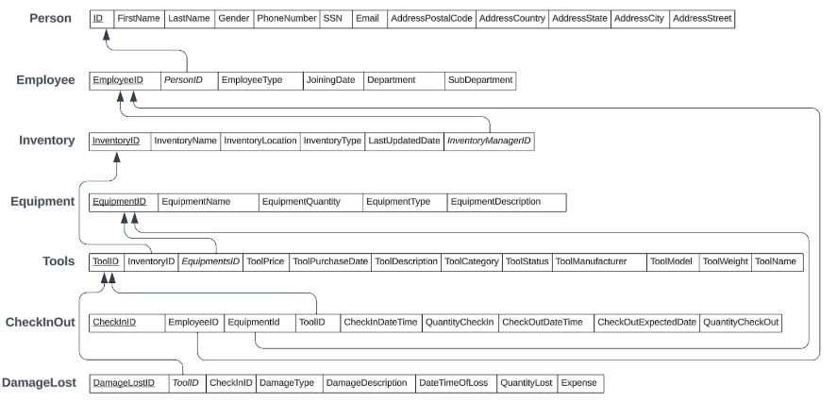

* **SQL commands**
  + ALL base tables

**Table Creations:**

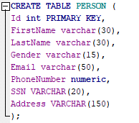 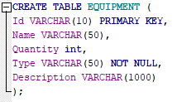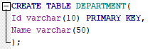

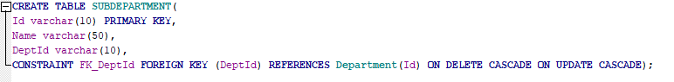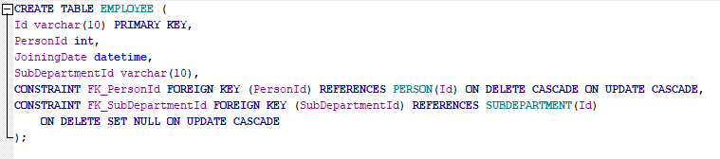

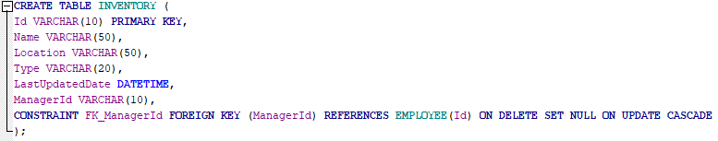

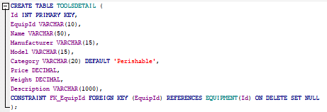

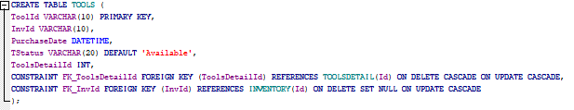

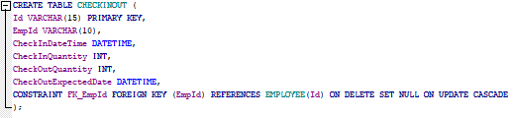

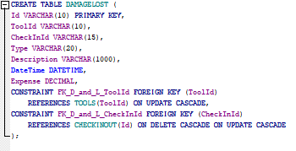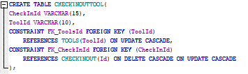

**Tables’ data population:**

**SELECT * FROM PERSON;**

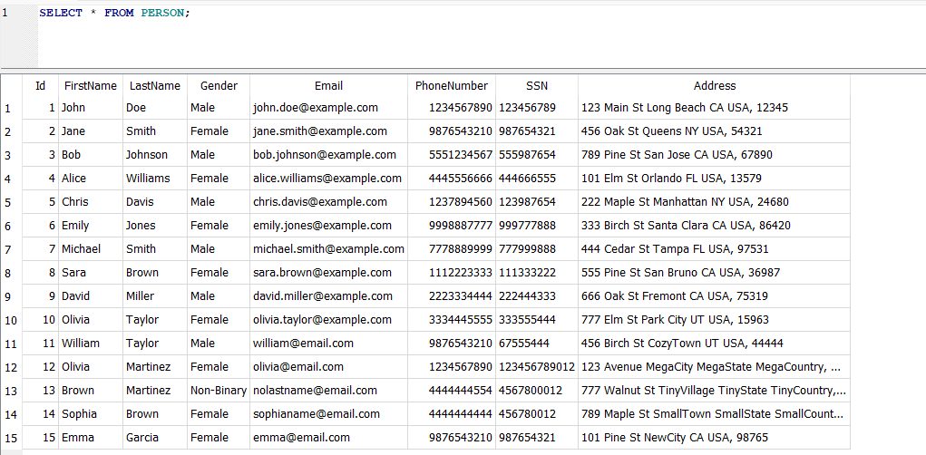

**SELECT * FROM DEPARTMENT;**

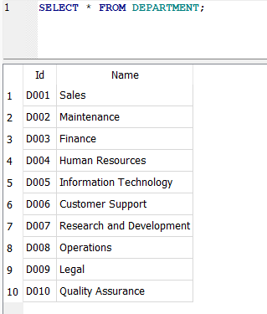

**SELECT * FROM SUBDEPARTMENT;**

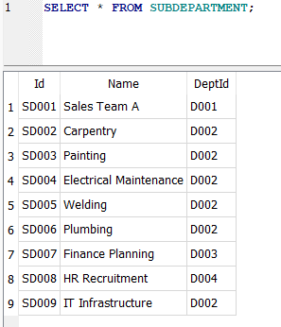

**SELECT * FROM EMPLOYEE;**

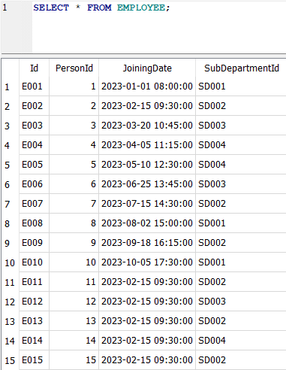

**SELECT * FROM EQUIPMENT;**

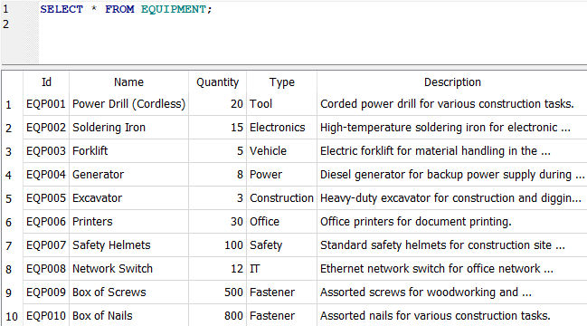

**SELECT * FROM INVENTORY;**

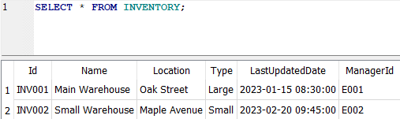

**SELECT * FROM TOOLS;**

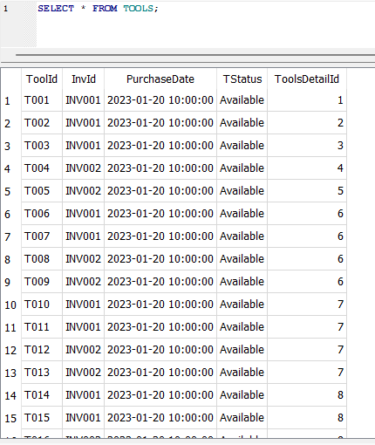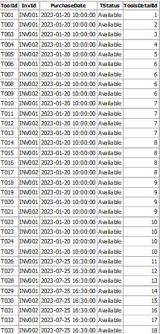

**SELECT * FROM TOOLSDETAIL;**

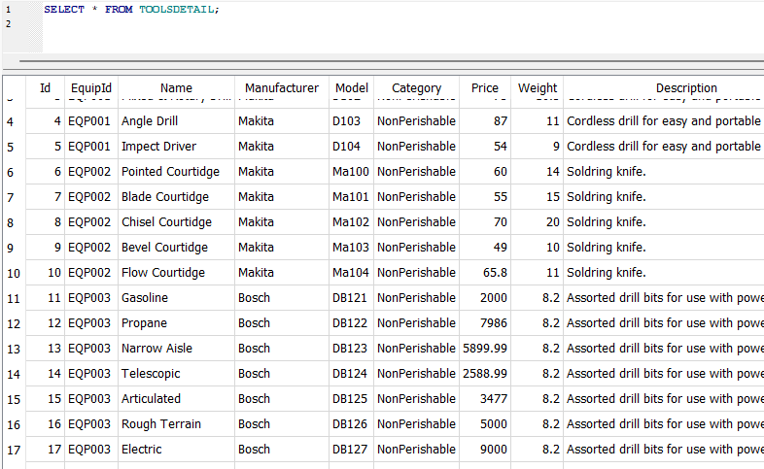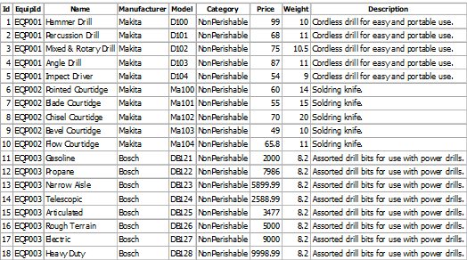

**SELECT * FROM CHECKINOUT;**

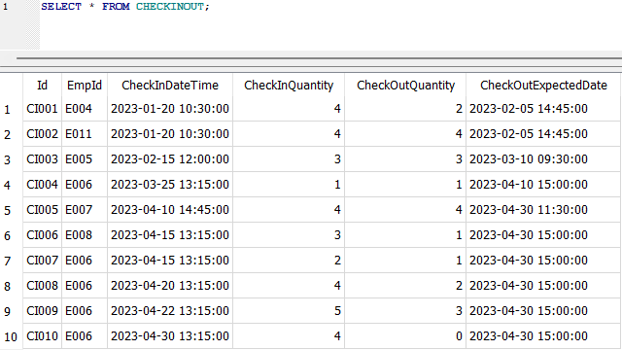

**SELECT * FROM CHECKINOUTTOOL;**

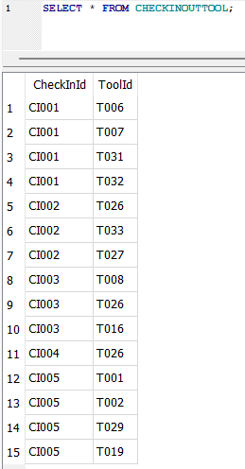

**SELECT * FROM DAMAGELOST;**

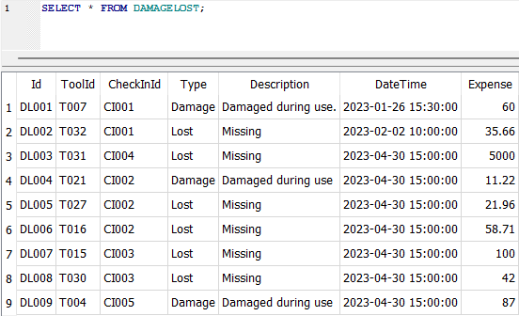

* + SQL Basic, intermediate and advanced commands
    - **Retrieve the total amount of expenses**

SELECT sum(Expense) FROM DAMAGELOST;

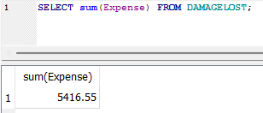

* + - **Retrieve Tools with basic details with price more than 70$**

SELECT Name, Model, Manufacturer FROM TOOLSDETAIL WHERE Price > 70;

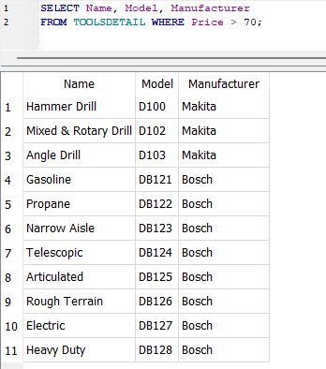

* + - **Retrieve Tools with having Damage under usage**

SELECT * FROM DAMAGELOST WHERE Type like “Damage”;

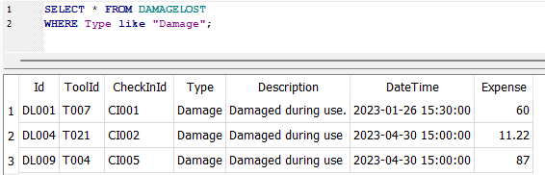

* + - **Retrieve all Equipments with Fastener as type**

SELECT Name, Quantity FROM EQUIPMENT WHERE Type = “Fastener”;

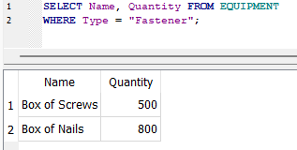

* + - **Retrieve first 5 departments in the list**

SELECT * FROM DEPARTMENT LIMIT 5;

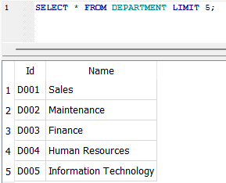

* + - **Retrieve the list of inventory details with no of tools**

SELECT iv.Name, iv.Location, iv.Type, count(TOOLS.ToolId) as ‘No. of Tools’ FROM TOOLS join INVENTORY iv  
on TOOLS.InvId = iv.Id group by TOOLS.InvId;

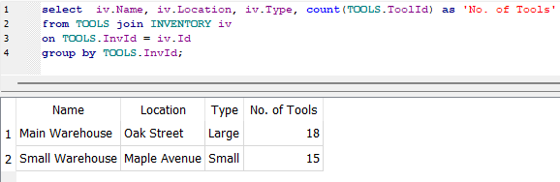

* + - **Retrieve list of the lost items**

SELECT Name FROM TOOLSDETAIL td JOIN TOOLS tl on td.Id = tl.ToolsDetailId JOIN DAMAGELOST dl on dl.ToolId = tl.ToolId and dl.Type = ‘Lost’;

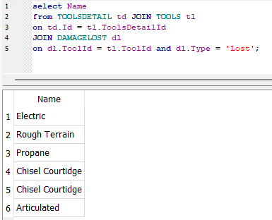

* + - **Retrieve the list of EmployeeId who made Damage**

SELECT CHECKINOUT.EmpId FROM DAMAGELOST join CHECKINOUT on CHECKINOUT.Id = DAMAGELOST.CheckInId and DAMAGELOST.Type = ‘Damage’;

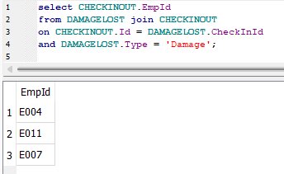

* + - **Retrieve the list of available tools of the Particular type**

SELECT EQ.Name, count(TOOLS.ToolID) as “Available Tools” from EQUIPMENT as EQ LEFT JOIN TOOLSDETAIL as TD on TD.EquipId = EQ.Id left join TOOLS on TD.Id =TOOLS.ToolsDetailId and TOOLS.TStatus = ‘Available’ group by EQ.Name;

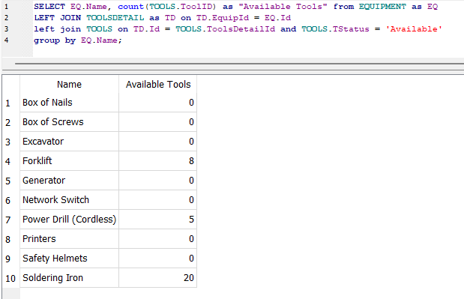

* + - **Retrieve the list of EmployeeId who made Lost**

select EmpId from CHECKINOUT cio where cio.Id in (select CheckInId from DAMAGELOST where Type = ‘Lost’);

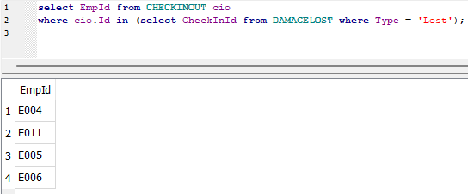

* + - **Retrieve the number of the Maintenance Employee**

SELECT count(E.Id) as ‘Maintenance Employee count’ FROM EMPLOYEE E JOIN SUBDEPARTMENT SD ON E.SubDepartmentId = SD.Id

and SD.DeptId in (SELECT D.Id FROM DEPARTMENT WHERE Name LIKE ‘%Maintenance%’);

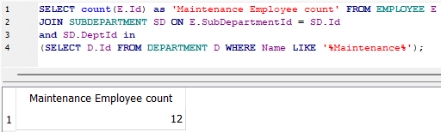

* + - **Retrieve the list of tools checking on the Particular date**

SELECT TD.Name, count(TD.Name) AS ‘Tools count’ FROM TOOLSDETAIL AS TD JOIN TOOLS ON TOOLS.ToolsDetailId = TD.Id

JOIN CHECKINOUTTOOL cit ON cit.ToolId = tools.ToolId JOIN CHECKINOUT cio ON cio.id = cit.CheckInId

WHERE cio.CheckInDateTime = ‘2023-01-20 10:30:00’

GROUP BY TD.Name;

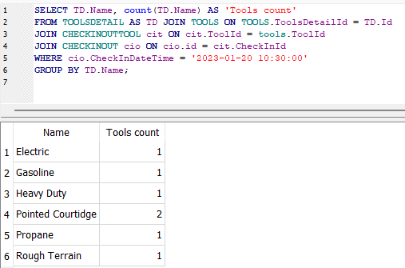

* + - **Retrieve the list of Employee who made Damage or Lost**

select E.Id, FirstName || ‘ ’ || LastName as ‘EmployeeName’ from PERSON P join EMPLOYEE E on E.PersonId = P.id

where E.id in (select EmpId from CHECKINOUT C where C.Id in (select CheckInId from DAMAGELOST));

